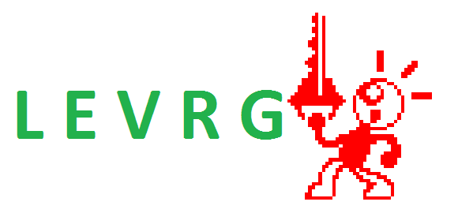
Freelance Estimate

Client: MPR ART
Project: The Lady – Game Development
Date: 11/4/2013

Overview:
Michael Rogers, a.k.a. MPR ART, is subcontracting Roger Levy, a.k.a. LEVRG, to be lead developer for a surreal puzzle-adventure game for the PC platform, entitled The Lady.

Scope of Work:
Roger Levy will be responsible for developing the program code and leading any potential assistants. His proprietary 2D OpenGL game engine for Windows will be used. The programming language used will be SwiftForth (www.forth.com), a commercial, industry-grade, high-performance Forth system.

The game will have 5 levels, 3 of which will use a similar engine, with Levels 4 and 5 using variations on the main engine. The other usual screens will also be included – Title, Game Over, Ending, Credits, and so on.

A preliminary demo version will be developed for use in a trailer video.

Proprietary bindings, exporters, and/or tools will be developed in order to support the Spriter animation system by BrashMonkey.

The level of detail in this baseline version is fairly minimal and will be outlined in the combination of a game design document and a Trello project, both of which will be a joint collaboration. Additional features, enhancements and polish that fall outside the scope (which will be decided by LEVRG) are contingent on factors including but not limited to: feasibility, remaining hours, availability, and additional payments.

Requirements:
Windows (XP and up), 1GB RAM, 100MB disk space, OpenGL 2.0-compliant video driver, 640x480 screen resolution (1024x768 recommended)

Deliverables:
Zip file containing the executable and related data

Date of Beginning of Production: On receipt of Initiation Fee (See Terms below)

Date of Delivery: Sometime in the month of February, 2014 for the baseline planned version; enhanced version around Spring if additional funding is obtained (and separate contract approved.)

Development Cost Breakdown:
Demo Development: 8 hours
Main Game Development: 160 hours

Cost Estimate:
8 special-rate hours x $12.50/hr = $100
160 special-rate hours x $12.50/hr = $1000

Payment Terms:
Per the agreement arising from discussions on October 29-31 2013 with Michael Rogers (of MPR ART), the baseline version of the game will be developed for a flat fee of $1000. An additional $100 fee is added for developing the version of the game for use in the trailer, which will be delivered sometime before the end of development on the actual game.

The “guaranteed” payment will be made in two installments. The initiation fee will be $500 + $100 for the demo. A milestone payment of $500 will be made no later than December 7, 2013 and will be required in order to continue development through to the end. Payments will be made either by Paypal or Dwolla.

In exchange for the negotiated rate, Roger Levy will be entitled to 40% of sales profit. (For example, if the game sells 100 units at $5 per copy and MPR ART makes 80% of that as profit, according to the 40% profit-share agreement, MPR ART would be obliged to pay him an additional $160, which is 40% of $400.)

Additionally, Roger Levy is entitled to 50% of any proceeds minus fees from online fundraisers (such as IndieGogo). Depending on the amount collected and future discussions with MPR ART, an additional contract may be written up for an enhanced version of the game with an extended timeline.

Initiation fee: $500 + $100 = $600
Milestone fee (due December 7th): $500
Total baseline fixed cost: $1100

Work for Hire Contract:

LEVRG (Roger Levy) agrees to complete the work outlined in the above scope in return for the approved costs. LEVRG understands that this will be a “Work for Hire” and MPR ART (Michael Rogers) shall own all rights to said work. LEVRG will retain the right to display said work in his portfolio to demonstrate capabilities and facilitate new business.

LEVRG warrants that the work will be an original work that has not been in the public domain or previously created, and that the work will be free of any unauthorized extractions from other sources.

If and to the extent the work for any reason is not considered a work for hire owned by MPR ART, and with respect to any rights other than copyright, LEVRG hereby transfers and assigns all right, title, and interest, including all intellectual property and proprietary rights, in and to the work. LEVRG hereby agrees to execute any document and do any other act that may be reasonably requested by MPR ART to register, perfect, or protect MPR ART’s right, title, and interest in and to the work.
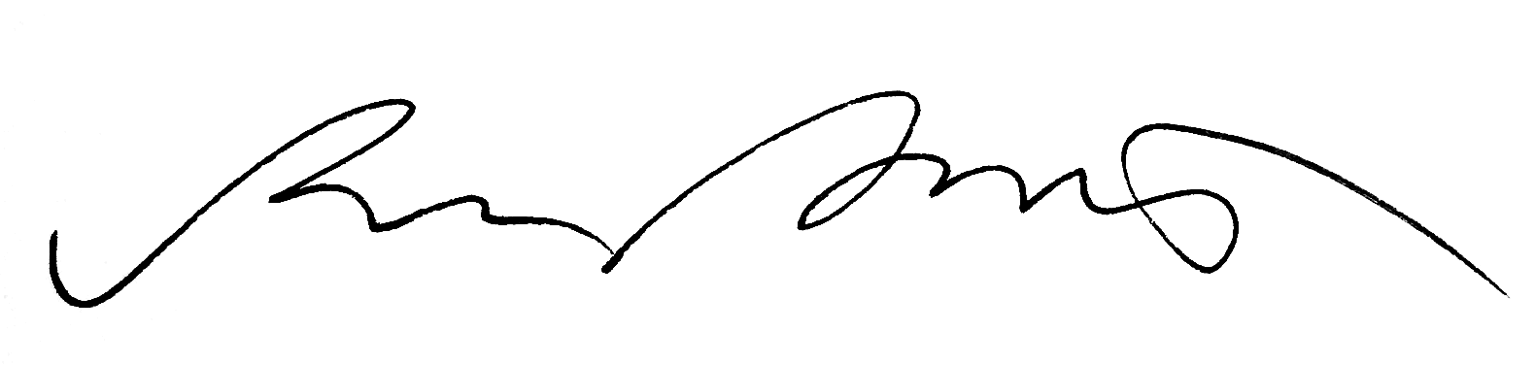

Approved by Roger Levy |  | Approved on behalf of MPR ART
Developer
Title |  | Title
11/04/13
Date |  | Date

